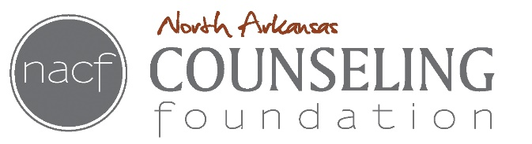
WRITTEN STATEMENT OF UNDERSTANDING FOR COUPLE THERAPY

Couple therapy starts with an assessment of the relationship past and present.
- We understand that information discussed in couple’s therapy is for therapeutic purposes and is not intended for use in any legal proceedings involving the partners.
- We agree not to subpoena the therapist to testify for or against either party or to provide records in a court action.
- By entering into couple’s therapy, we accept that we both understand that working toward change may involve experiencing difficult and intense feelings, some of which may be painful in order to reach our goals.
- We accept that such changes can have both negative and positive effects and agree to clarify and evaluate potential effects of changes before we undertake them.
- Counselor may suggest individual sessions if needed to support the therapy process.
- Information discusses between an individual and the counselor will not be discussed in couple therapy unless permission has been given.
- If the relationship breaks up and either or both of you wish to re-contract with me for individual counseling, the decision with whom I continue working with is at my discretion. In some circumstances, a referral will be made.
- Since session time in limited to 50 minutes, try to be concise in presenting your thoughts and feelings.
- Therapy works best if you strive for closure in your communications, that is, a point of satisfaction that you have said what you need to say and asked for what you need to ask for.
We agree to the above guidelines:

____________________________________ ________________________________________ Signature of Party 1 Signature of Party 2

____________________________________ _________________________________________ Date Date

NACF - 2015

